LABORATORY WORK
Numerical methods for solving nonlinear equations

The goal is to develop programs for the numerical solution of nonlinear equations

Exercise
- Solve nonlinear equations using the bisection method with accuracy ε=0.001.
- Solve nonlinear equations by Newton's method ε=0.0001.
- Determine for what values of the parameter a the equation has 1, 3 real roots.
- Variant number according to the subgroup list.

Variant | Уравнение 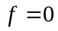
1 | 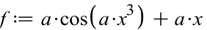
2 | 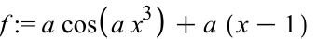
3 | 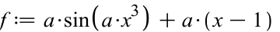
4 | 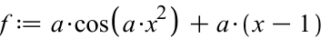
5 | 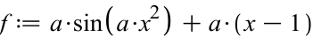
6 | 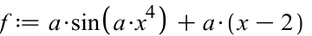
7
8
9
10 | 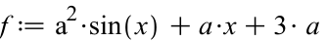
11 | 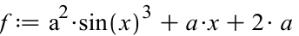
12 | 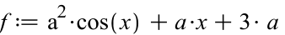
13 | 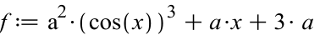
14 | 